Assignment 12 (December 5 – December 17)

1. Use the Lagrange multiplier method to write the first-order conditions for the maximum of the function 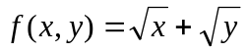, subject to 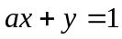, where is a real parameter. For what values of a solution exists? Check sufficiency condition.

2. Find the points of relative optimum and classify them using second-order conditions:
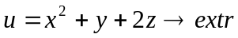 s.t. 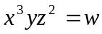, is a real parameter.

3. Find the points of relative optimum and classify them using second-order conditions:
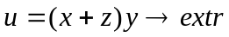 s.t. 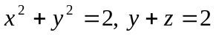, where all the variables are positive.

4. A firm with the smooth production function 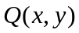 wants to find the least-cost input combination for a production of a specified level output 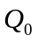 representing, say, a customer's special order. Show that at the point of optimal input combination, the input-price-marginal-product ratio must be the same for each input.

5. Show that the function 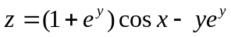 has an infinite number of points of maximum and no point of minimum.

